Nicholas Graumann

ECE 471

Project Design Document

1. Project Description

The goal of this project was to design and build an oscilloscope-like device capable of sampling signals at a much higher rate than the built-in ADC on the LPC1769. The signal(s) will then be plotted to the screen with adjustable horizontal timebase.

1. Requirements
2. The system will sample an input signal with an external Analog to Digital converter (serial communication only).
3. User input shall be handled by the built-in buttons on the development board.
4. Triggering shall be accomplished via a manual “force triggering” button
5. Horizontal timebase shall be adjustable in the following multiples: 1, 2, 5, 10, 20, 50, 100, 200, and 500 of relevant units s, ms, us, etc.
6. Sample memory larger than the horizontal size of the screen (160 pixels) shall be used to ensure accurate signal representation.
7. Data Flow Diagram

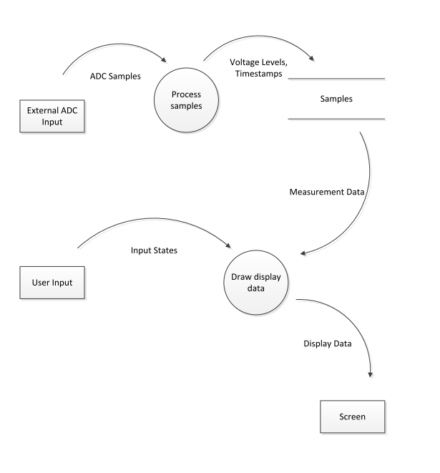

1. State Machines/Flowcharts

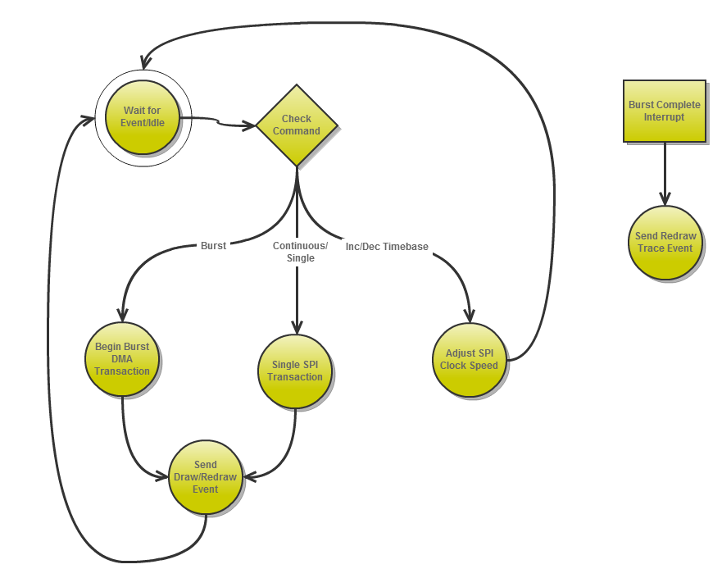**AdcReader**

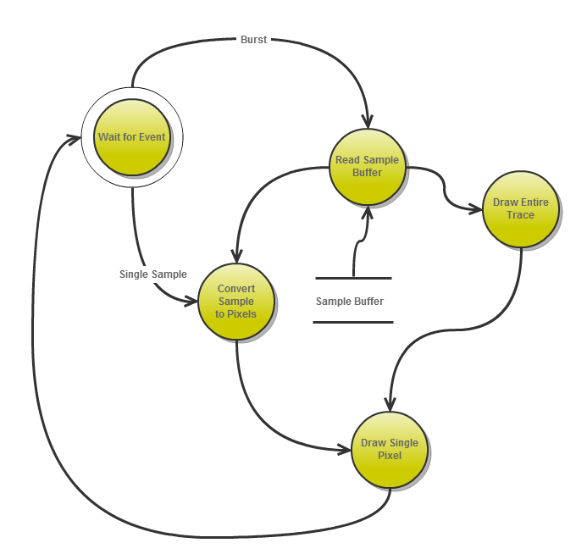**ScopeDisplay**

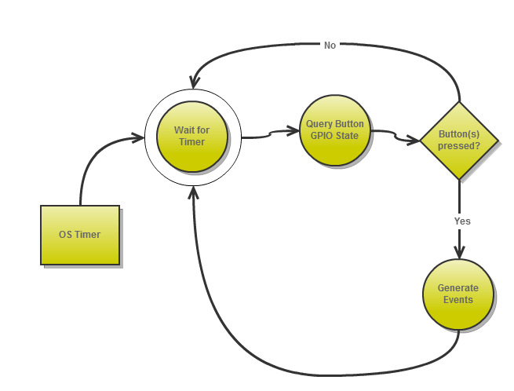**UserInput**